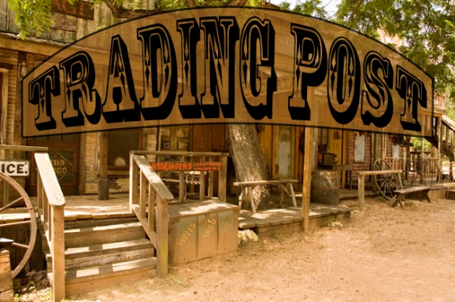

Veterans Club
This is a space where veterans can have items posted that they would like to sell, buy, rent or trade.

Name | Item | Contact # | Email | S,B,R,T

